Project: Other Analitycs

Course: Massive Data Analytics

Proffesor: Dr. Iman Gholampoor

Mohammad Mehdi Zare

* **Introduction**:

In this report, I aim to address four questions utilizing the available data, including Twitter data and Persian news data, with the help of algorithms covered in the course. In the provided notebook, various libraries have been used, but the algorithms have also been implemented manually. Overall, the PySpark library and RDD API have been employed for data processing.

* **The questions that I will be answering next:** 
  + - * 1. If Twitter decides to verify some users for free, which users are candidates for verifying, and which users have lost their verified label?
        2. How many distinct words are present in news data? (batch processing and stream processing approach)
        3. Each user, based on their tweets and behavior on Twitter, is interested in a specific set of categories. News also belongs to various categories. If Twitter intends to suggest daily news to its users, which news does it recommend to each user?
        4. Some news agencies copy news from others, which is a form of Plagiarism. I want to identify these instances in the news data.
* **Sections:** 
  1. **Dataset preparation and preprocessing:**
     1. At first, I clean news data. I remove punctuation and stopwords. Then, remove unnecessary columns from the data and keep columns: uid, body, source, date_published, key_words, and categories. The result dataset is:

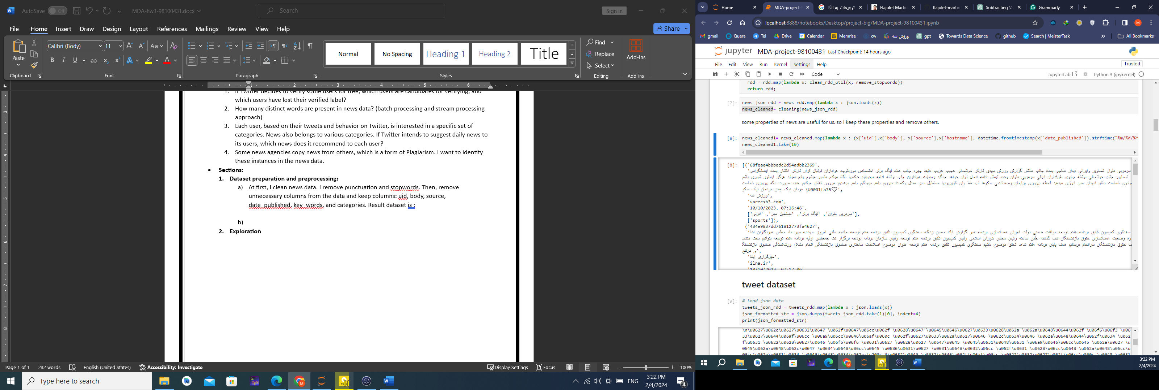

* + 1. Second, I clean the tweet dataset and remove incomplete rows in the data. I remove 214 rows:

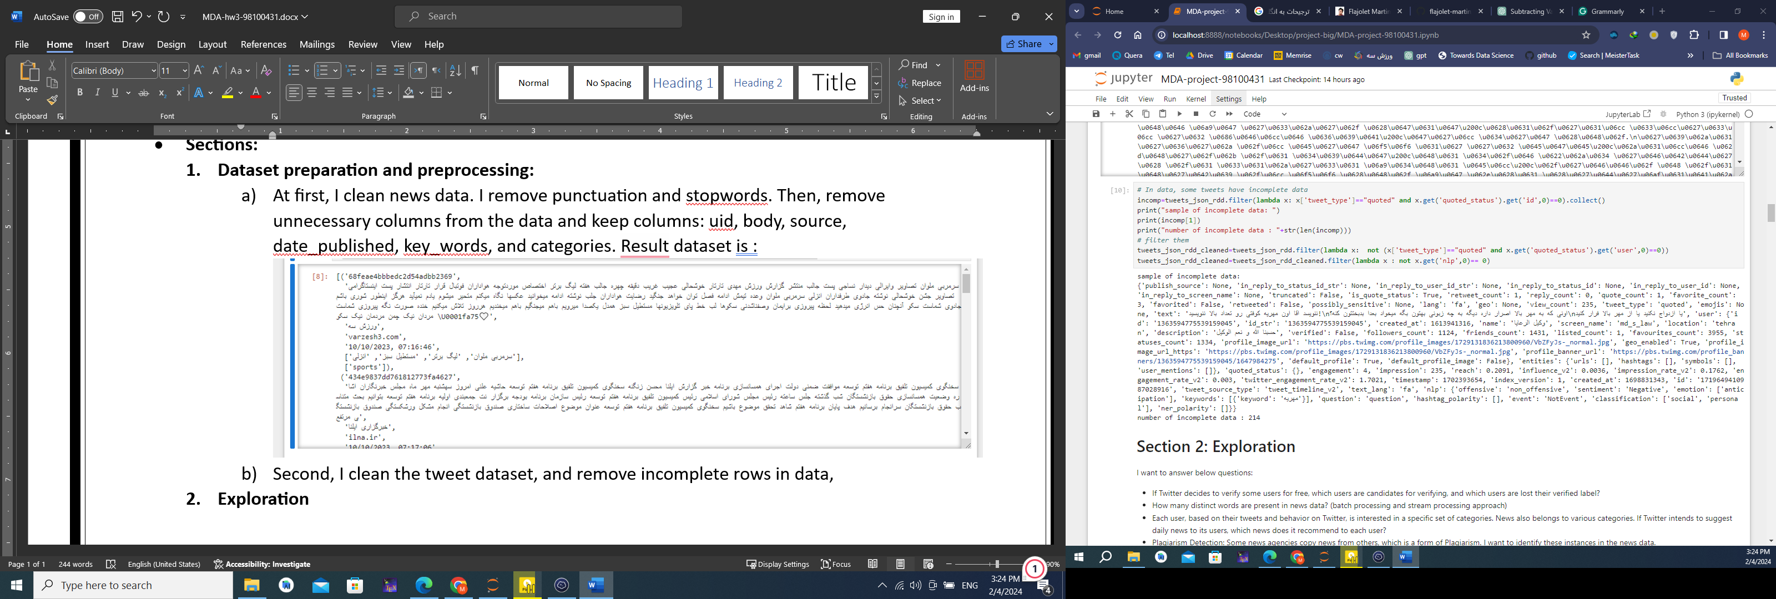

* 1. **Exploration**

Let’s go to answer the above questions:

* + 1. **If Twitter decides to verify some users for free, which users are candidates for verifying, and which users have lost their verified label?**

To answer this question, I use PageRank and TrustRank algorithms. users are linked to each other by their interaction with tweets. So with the PageRank algorithm, we can find a weight for the user. Also, verified users can be used as trust sets and then use the TrustRank algorithm. I use Networkx library to create a directed graph.

Steps:

* Find verified users as trust set. In data, some users have verified labels, so I filter them. You can see the number of users and verified users in the data, below picture:

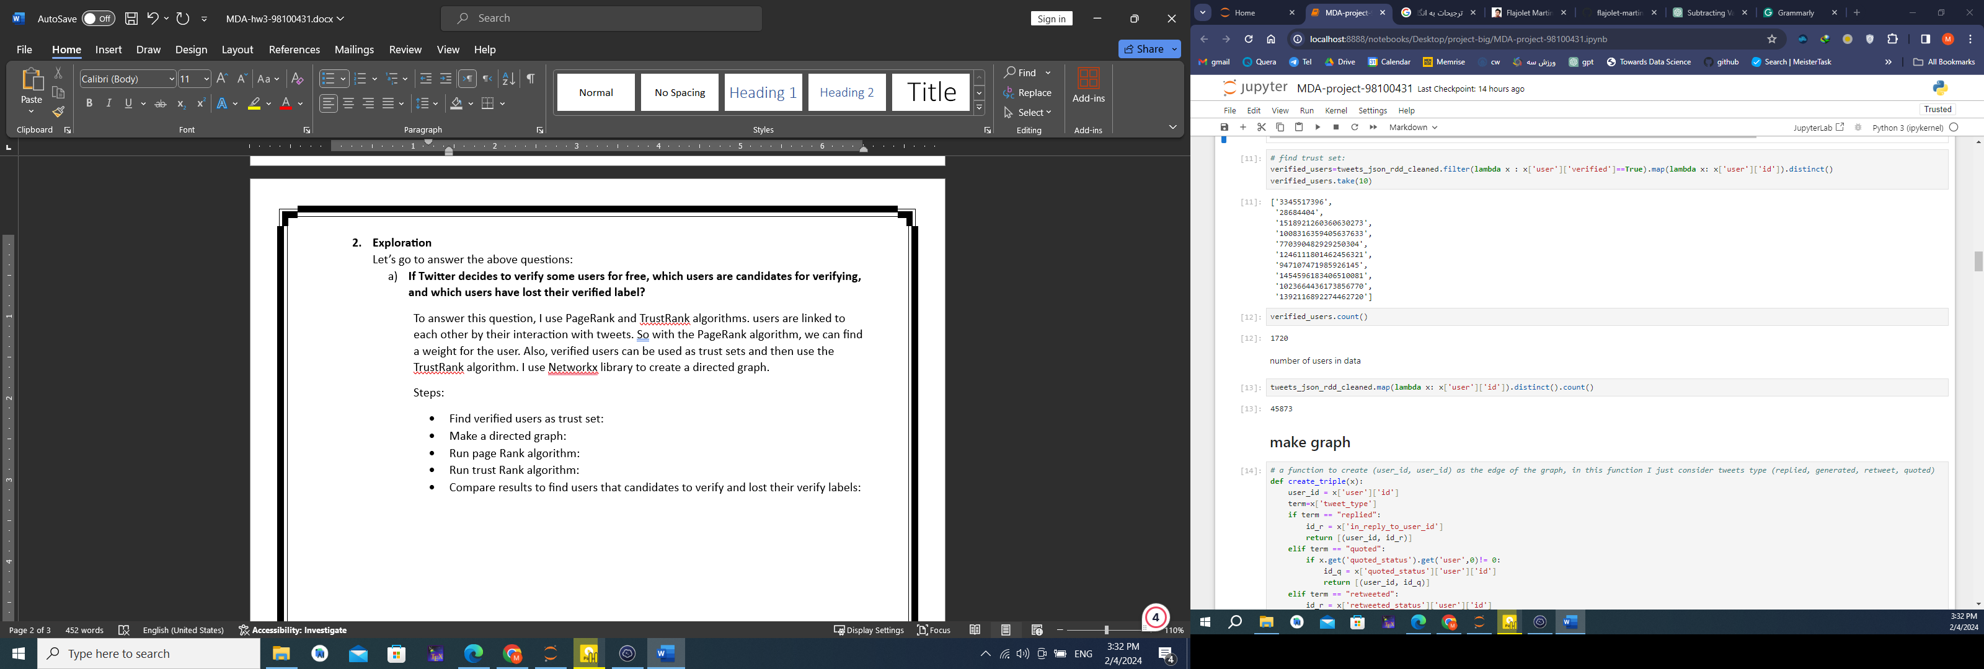

* Make a directed graph. Users interact with each other by replying, retweeting, and quoting. Therefore, I make edges from user interaction in data. And make a directed graph. In the below pictures you can see some edges and a part of the graph:

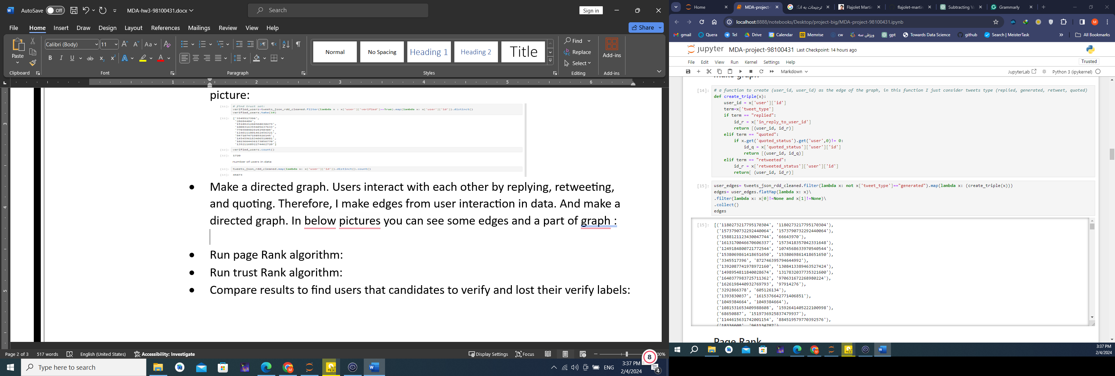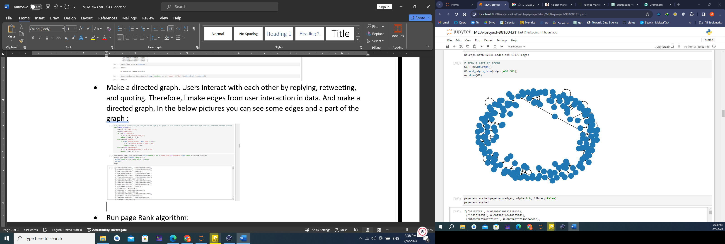

* Run page Rank algorithm. The result is:

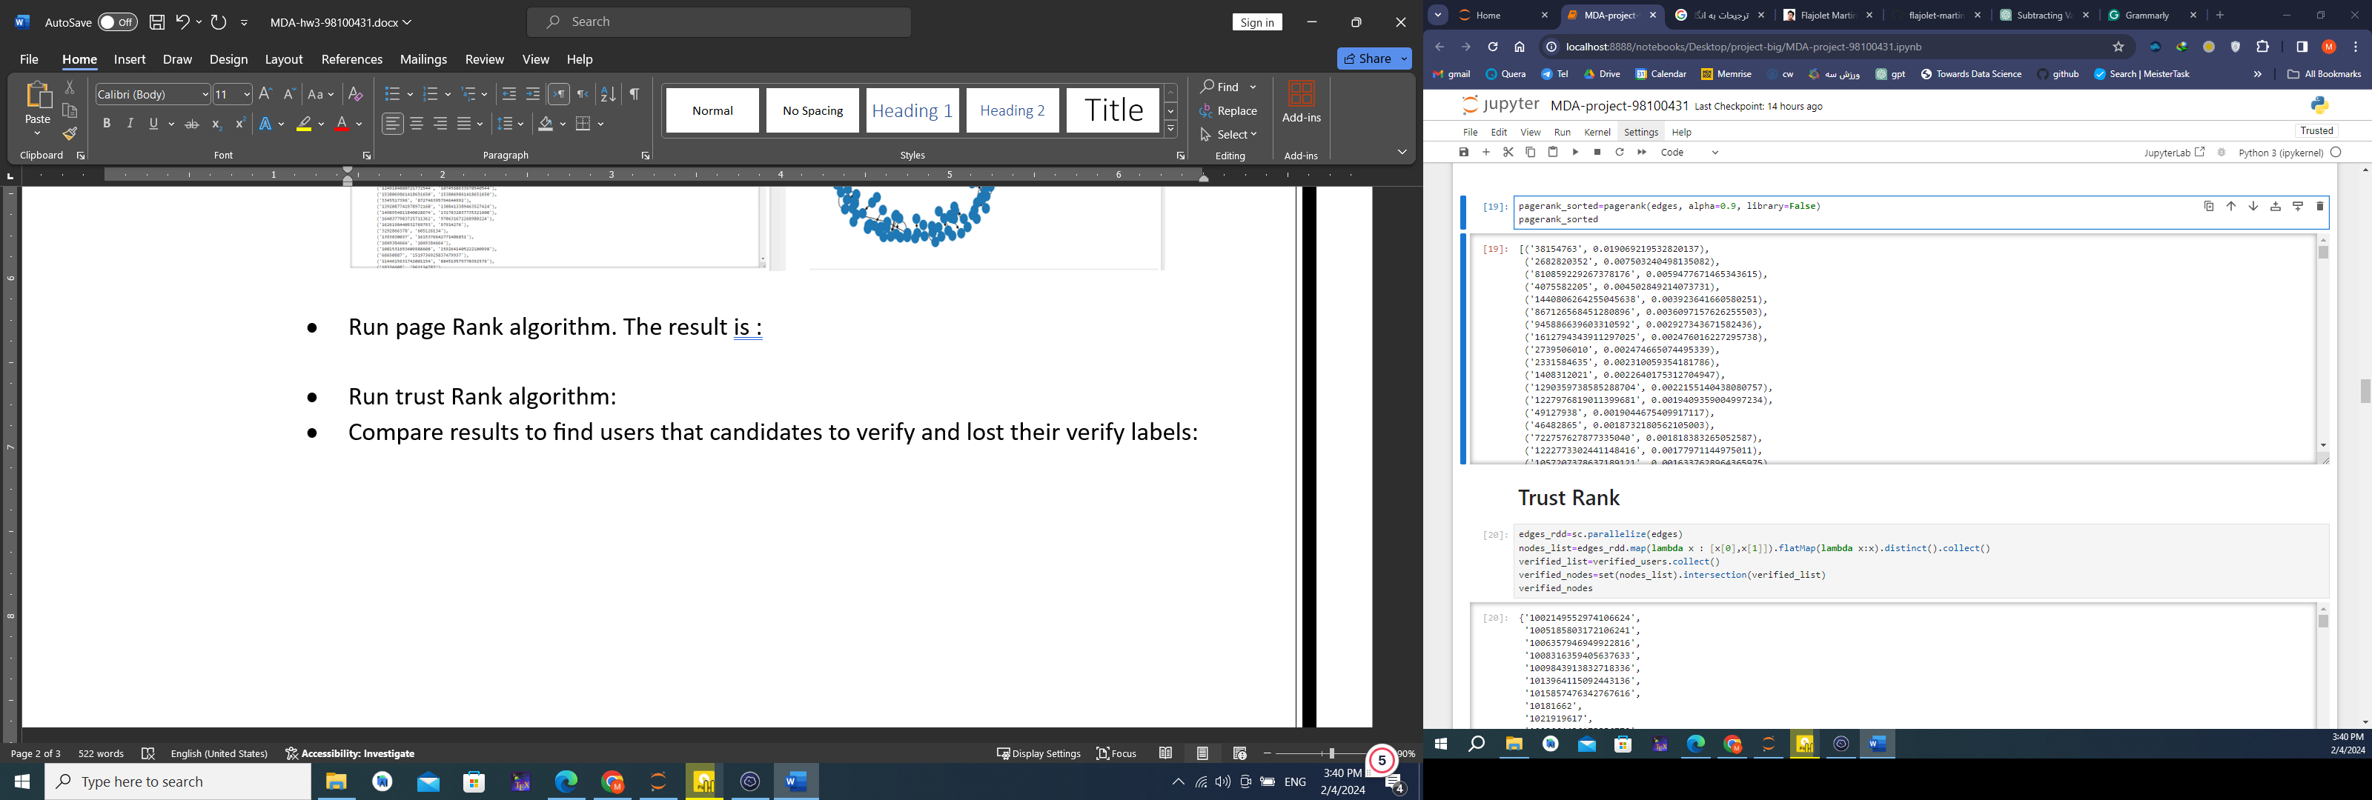

* Run trust Rank algorithm. The result is:

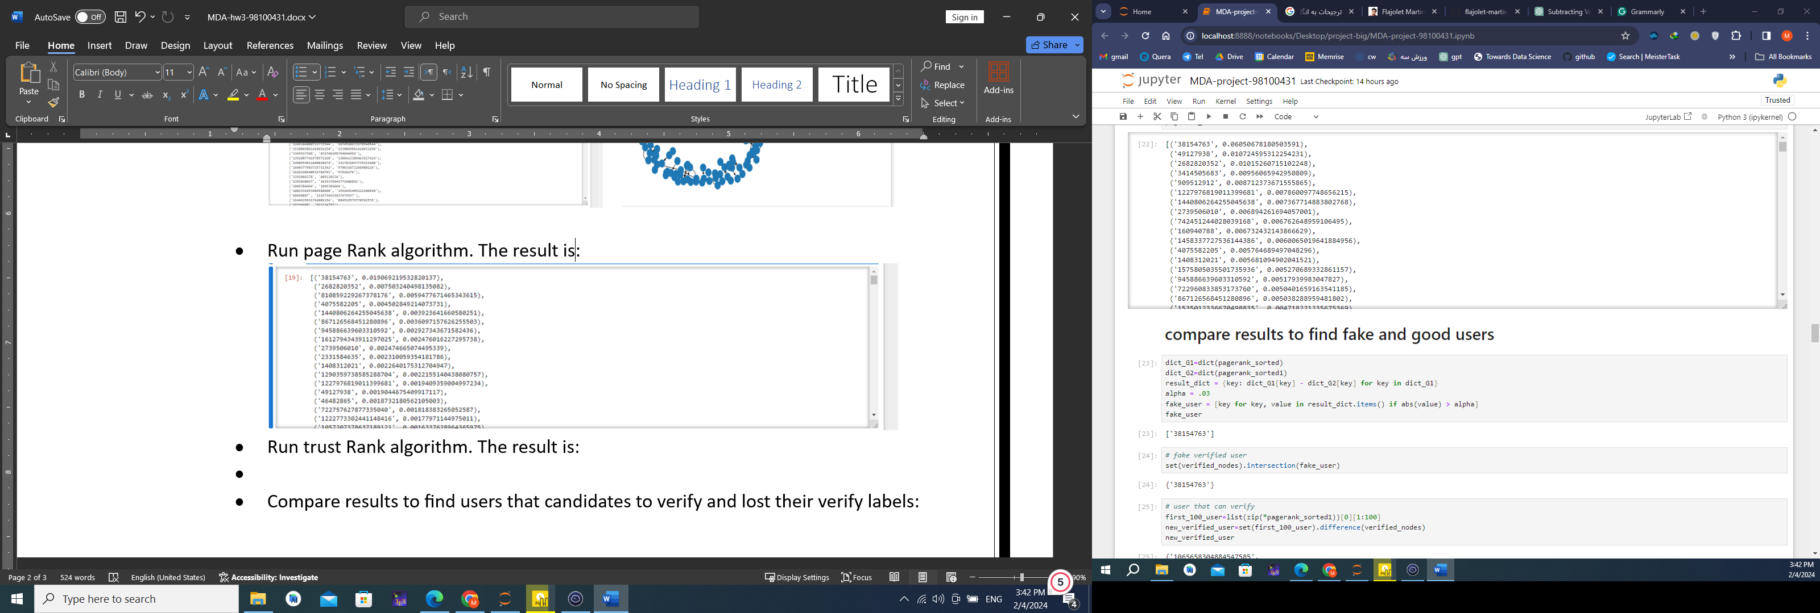

* Compare results to find users that candidates to verify and lost their verify labels:

Verified users whose rank difference in the two algorithms is greater than $.03$ are fake users. And users that rank 1 to 100 are new verified users.

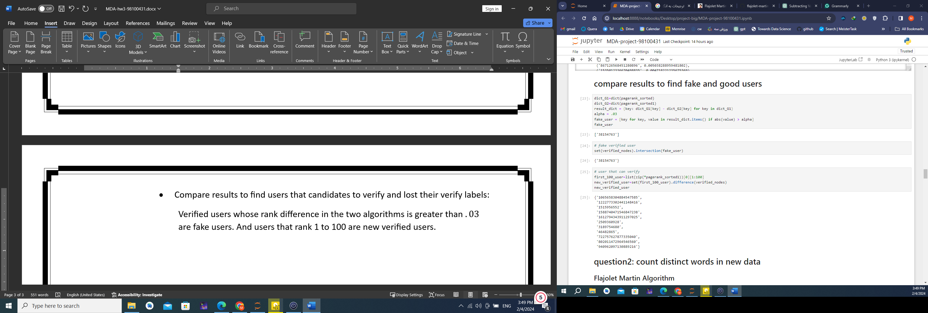



* + 1. **How many distinct words are present in news data? (batch processing and stream processing approach)**

To answer this question, I implement the Flajolet Martin algorithm. Steps:

* create a tokens list using rdd (all words in all news)

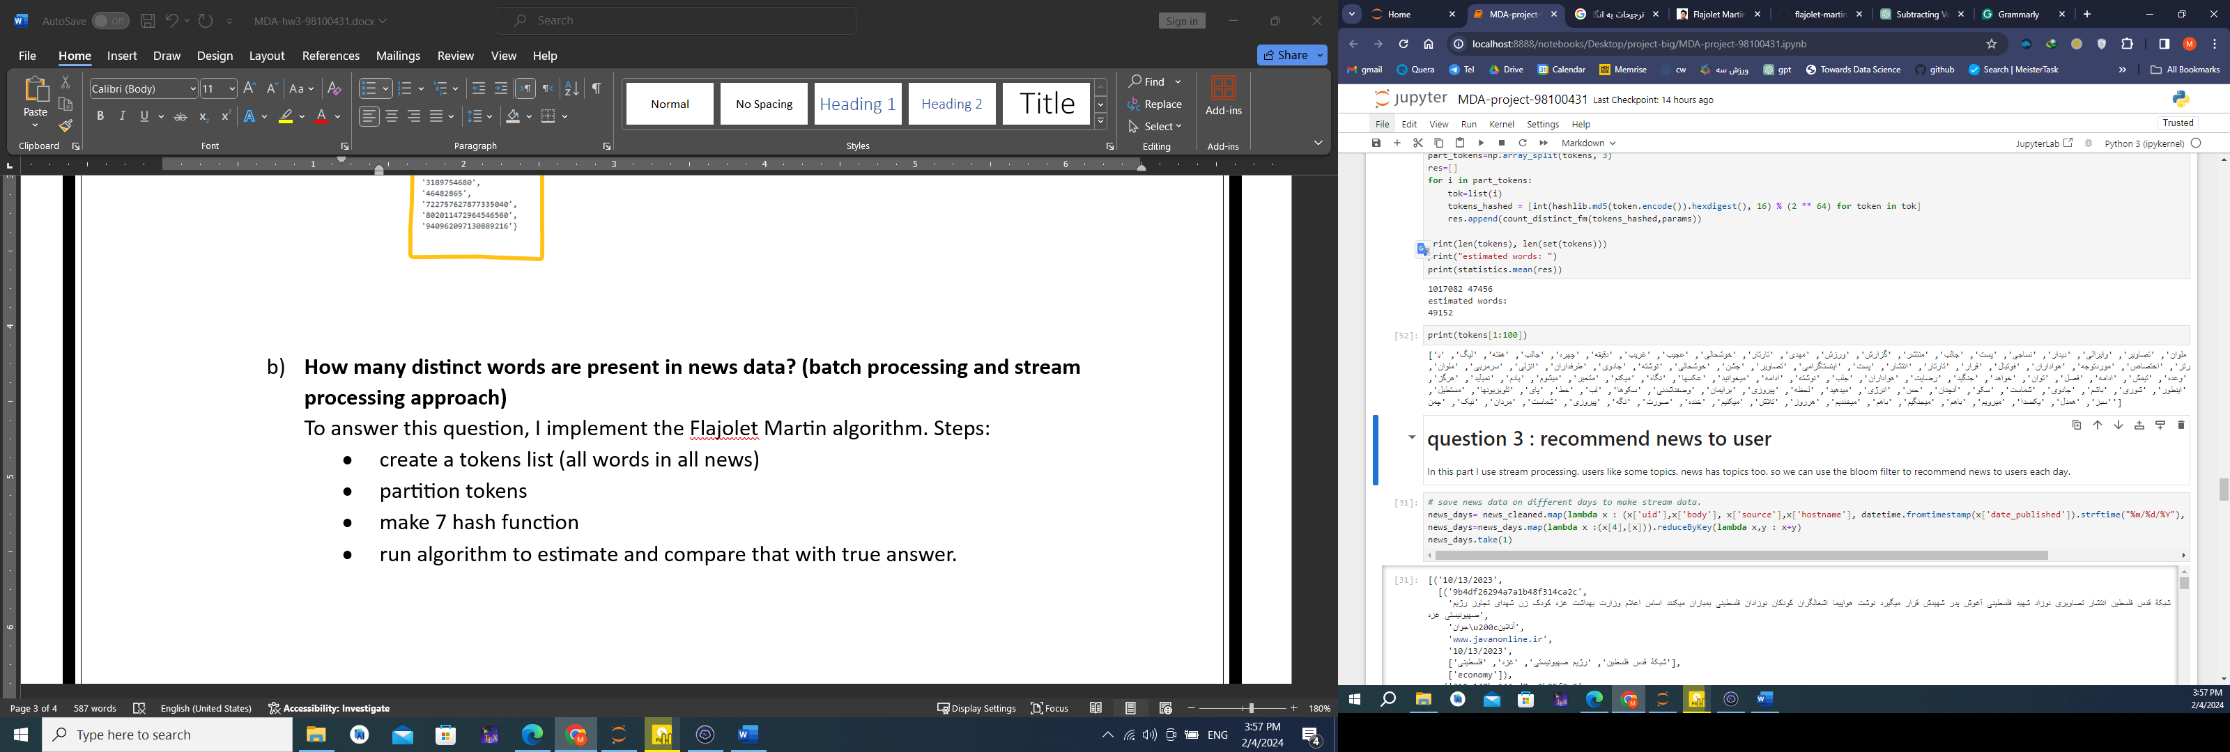

* partition tokens into 3 parts.
* make 7 hash functions
* run the algorithm to estimate and compare that with the true answer.

In each partition, I start with defining a closed hash range, big enough to hold the maximum number of unique values possible ( 2 ^ 64). Every word of the tokens is passed through a hash function that permutes the elements in a uniform distribution. For this hash value, I find the position of the rightmost 1s bit and mark the corresponding position in the bit vector as 1. Once all the words of the partition are processed, the bit vector will have 1s at all the positions corresponding to the position of every rightmost 1s bit for all words in the partition. Now I find the position, b, of the leftmost 1 in this bit vector. This position b corresponds to the max length of unset bits that I have seen while processing the words. Then find the median of the estimated value for each hash function. Finally, estimate distinct words by averaging values of partitions.

In the below picture, you can see the fluctuation of estimated values for generated data.

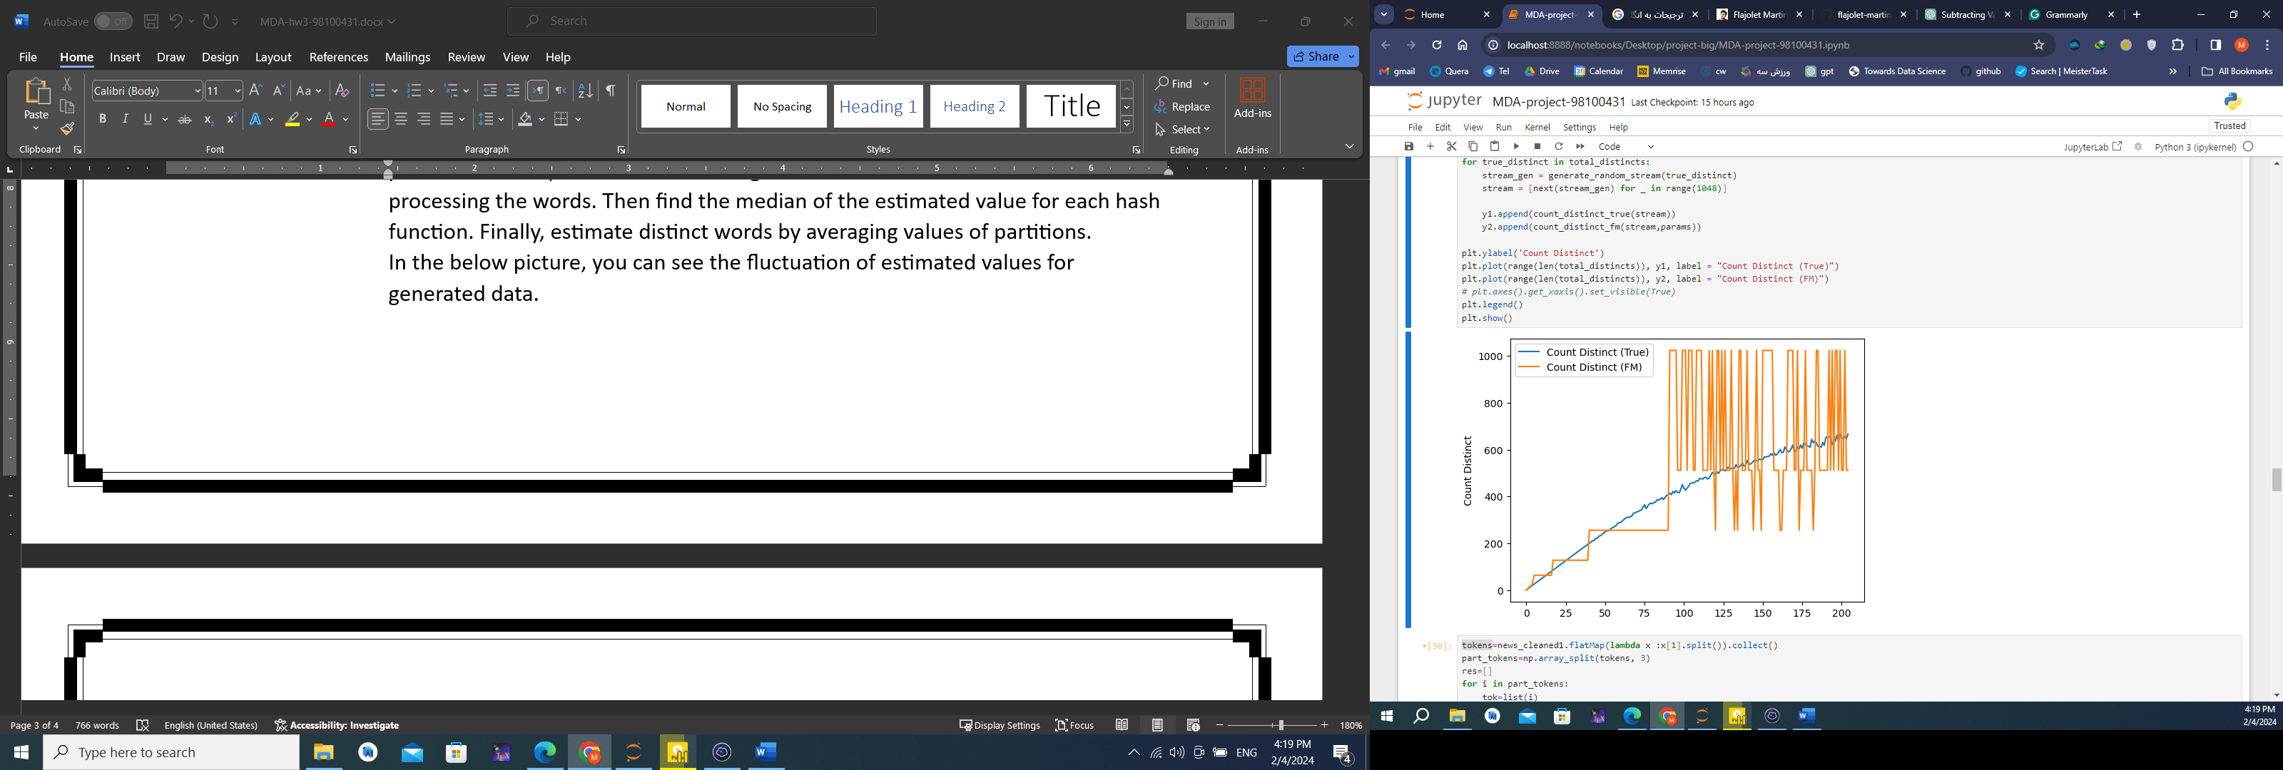

After running the algorithm in news data, the result is:

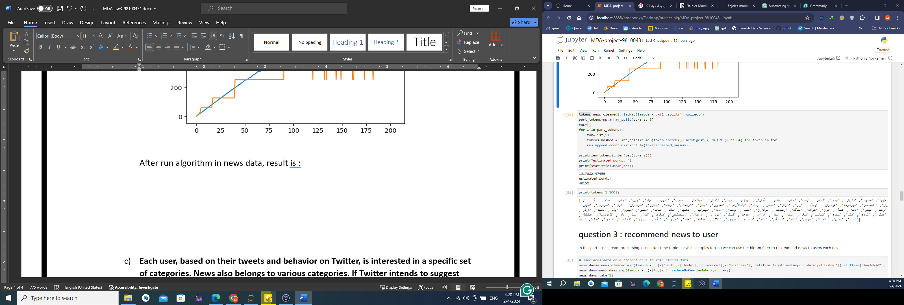

True distinct words



We can see that the estimated count-distinct using the Flajolet-Martin algorithm is very close to the actual deterministic words.

* + 1. **Each user, based on their tweets and behavior on Twitter, is interested in a specific set of categories. News also belongs to various categories. If Twitter intends to suggest daily news to its users, which news does it recommend to each user?**

In this part, I use stream processing. users like some topics. news has topics too. so we can use the bloom filter to recommend news to users each day. Steps:

* Make data as a stream data.
* Implement bloom filter
* Make categories in news data and tweet data the same. Twitter and Wikipedia use different words for categories. For example, economy and economical. You can see the categories in tweets and news:

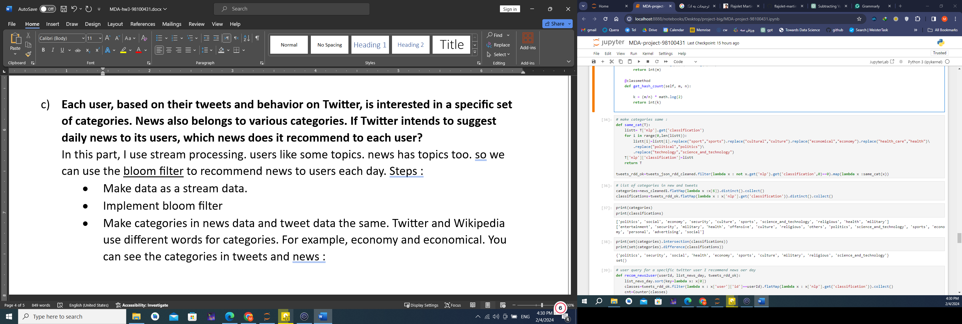

* I use categories that exist in the intersection set.



* For each user, we can run a query. In a query, for each day make a bloom filter for users according to their liked categories. In the stream data of news, filter news and recommend one news.

As we know, The bloom filter has false positive. I calculate the number of hash functions and the size of the bit array. According to the number of categories and False positive Probability.

The result of the sample query is:

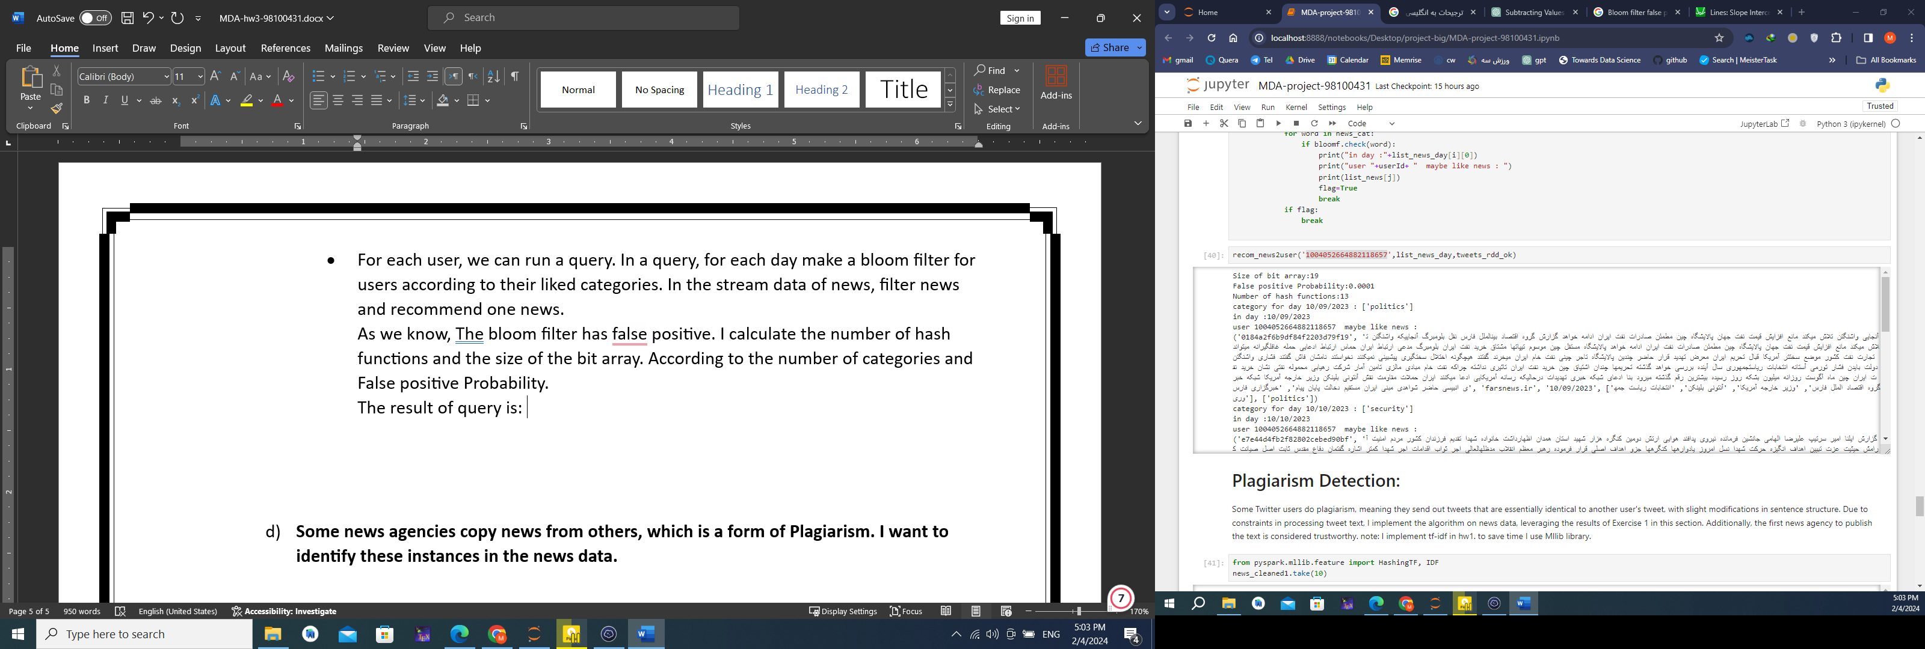

* + 1. **Some news agencies copy news from others, which is a form of Plagiarism. I want to identify these instances in the news data.**

Some Twitter users do plagiarism, meaning they send out tweets that are essentially identical to another user's tweet, with slight modifications in sentence structure. Due to constraints in processing tweet text, I implement the algorithm on news data, leveraging the results of Exercise 1 in this section. Additionally, the first news agency to publish the text is considered trustworthy.

note: I implemented tf-idf in hw1. To save time I used the Mllib library in the project.

The similarity between the two news can be obtained by computing the cosine similarity of their TF-IDF vectors. We know that the cosine similarity is a number between 0 and 1, due to normalization. If the cosine similarity is 1, the new are identical; if the similarity is 0, the new have nothing in common.

I chose news from hw2 results that I have found similar news for that. After calculating tf-idf for all news and candidate news, calculate the cosine similarity between the candidate and other news and find the top five news that has high cosine similarity. According to their published date, we can say which ones are plagiarism.

Cosine similarity of top five news:

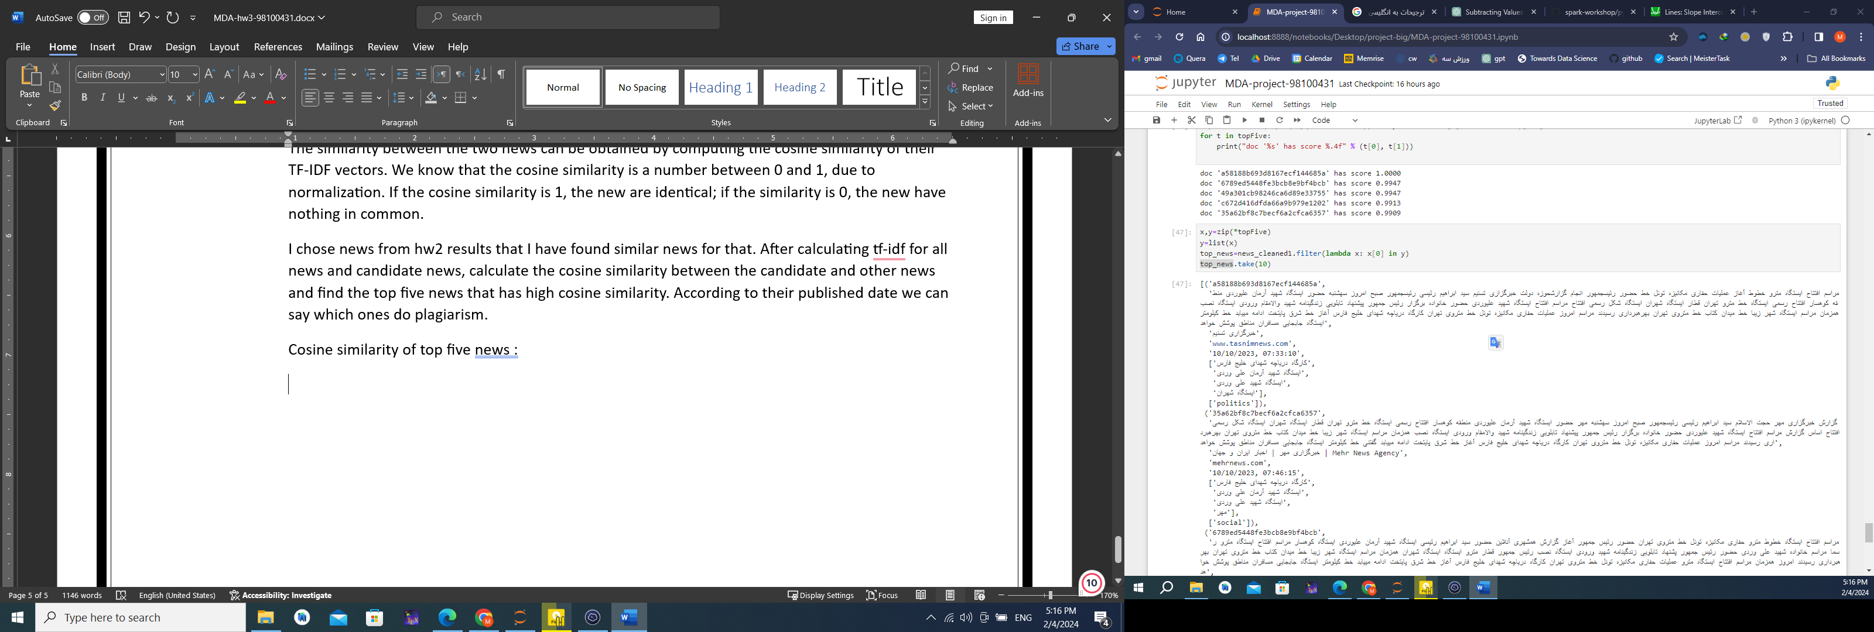

News are:

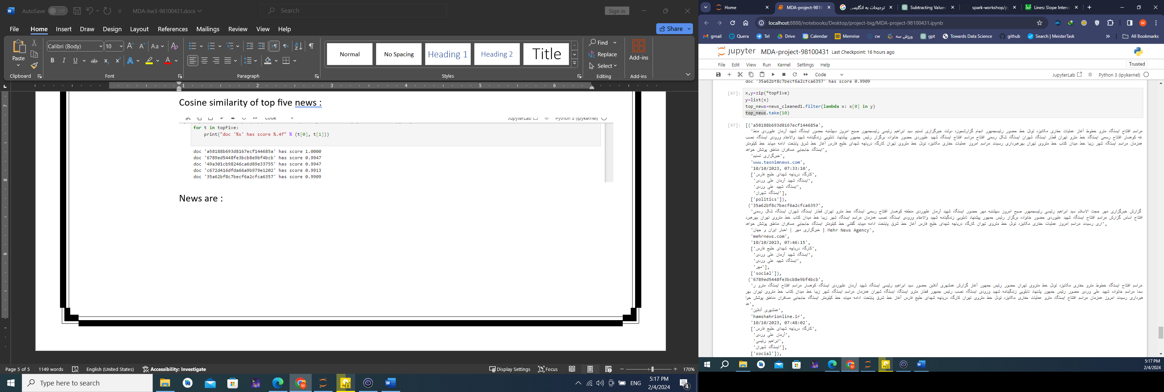

you can see that all the top five news are the same and about specific topics and published on specific dates.

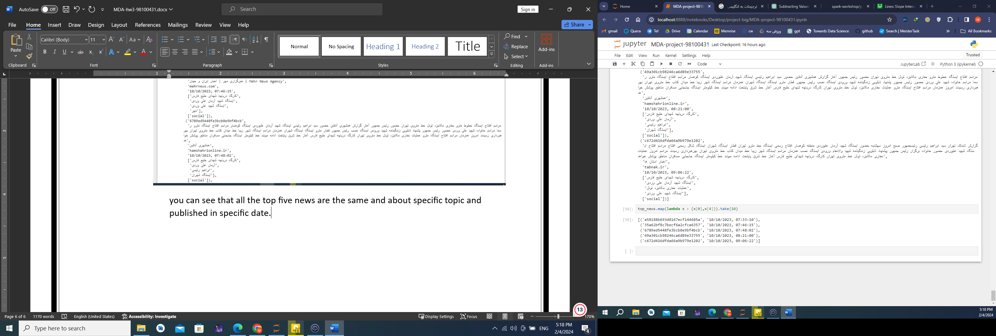

Therefore, news with Id a58188b693d8167ecf144685a is a source, and others may copy from that.

The news agency of this news is :

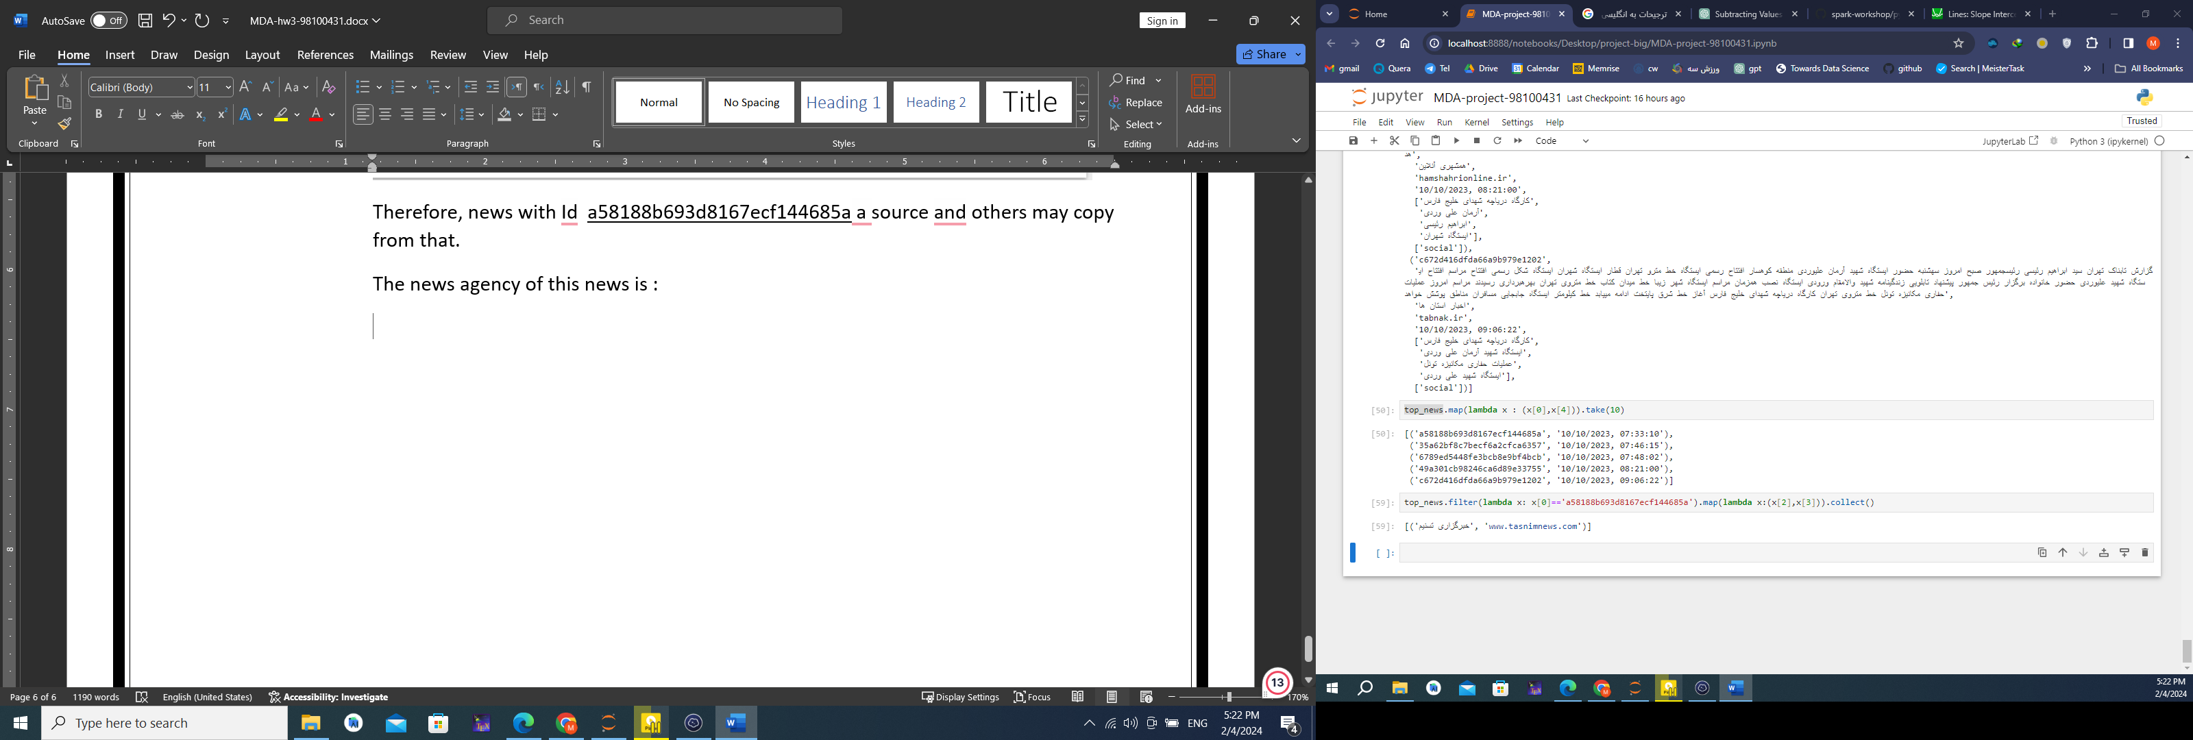

**Conclusion:**

In the surrounding datasets, there is a wealth of information that can be uncovered through various data analysis methods. We discussed and explored different approaches for processing stream and persistent data, each having its own advantages. In the project, we demonstrated that stream processing methods may have errors, but they still provide good estimates of information, enabling us to make strong assumptions backed by the science of statistics and probability regarding data behavior.

We also emphasized the importance of data and how it can enhance the user experience in applications. It can assist us in identifying fraudulent activities and plagiarism by individuals from other sources. Moreover, based on users' behavioral history, we can even suggest news or tweets that align with their preferences and interests. Thanks - winter 2024